

LAB EXPERIMENT RECORD

SET 20

Department | Artificial Intelligence and Data Science
Course Code / Course Name | DSA0601 / Data Handling and Visualization
Name / Register Number | ROHAN P T / 192424112
Date / Day | 13/10/2026

Aim
To analyze stock analysis using the requested visualizations and dashboard views.

Dataset
Stock Analysis
Date | Stock_A | Stock_B | Stock_C
2023-01-01 | 100 | 150 | 120
2023-01-02 | 105 | 152 | 118
2023-01-03 | 110 | 148 | 122

R Data Setup
Run this setup once before the R programs below. The dataset is defined inline so each record can be copied and run without a separate CSV file.
R data setup
dat <- data.frame(
Date = c("2023-01-01", "2023-01-02", "2023-01-03"),
Stock_A = c(100, 105, 110),
Stock_B = c(150, 152, 148),
Stock_C = c(120, 118, 122)
)
dat$Date <- as.Date(dat$Date)

PROGRAM 1: Three-Company Stock Price Chart
Create a labeled line chart comparing Stock A, Stock B, and Stock C over time.
R code
matplot(seq_len(nrow(dat)), dat[c("Stock_A","Stock_B","Stock_C")], type="o", pch=19, xaxt="n", xlab="Date", ylab="Price ($)", main="Stock Prices Over Time")
axis(1,1:nrow(dat),dat$Date); legend("topleft", c("Stock A","Stock B","Stock C"), col=1:3, lty=1, pch=19, bty="n")

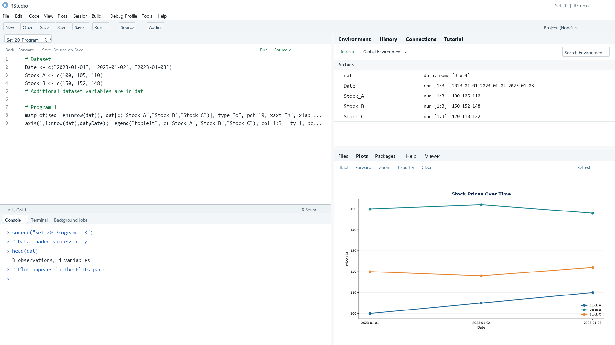

Output 1: Three-Company Stock Price Chart

Observation: Stock A rises on each date, Stock B is nearly flat before declining, and Stock C dips then recovers.

PROGRAM 2: Stock A Daily Percentage Change
Calculate and chart daily percentage changes for Stock A.
R code
pct <- diff(dat$Stock_A)/head(dat$Stock_A,-1)*100
barplot(pct, names.arg=dat$Date[-1], col="skyblue3", xlab="Date", ylab="Change (%)", main="Stock A Daily Percentage Change")

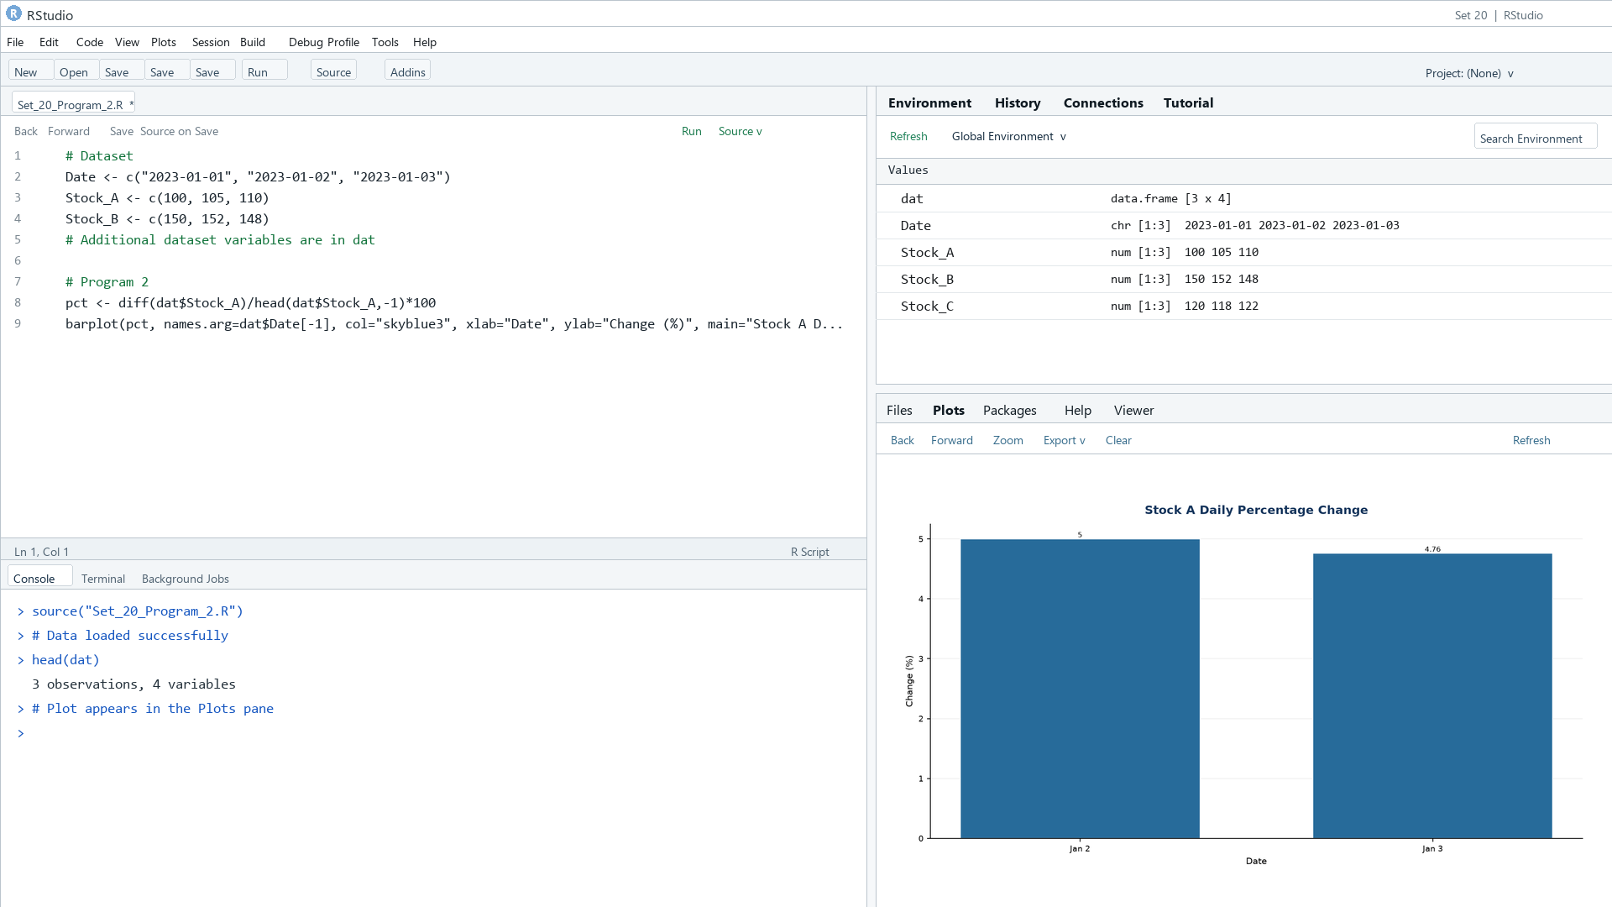

Output 2: Stock A Daily Percentage Change

Observation: Stock A rises by 5.00% on January 2 and 4.76% on January 3.

PROGRAM 3: Stock Price Data Table
Display the stock price table for each company and date.
R code
print(dat)

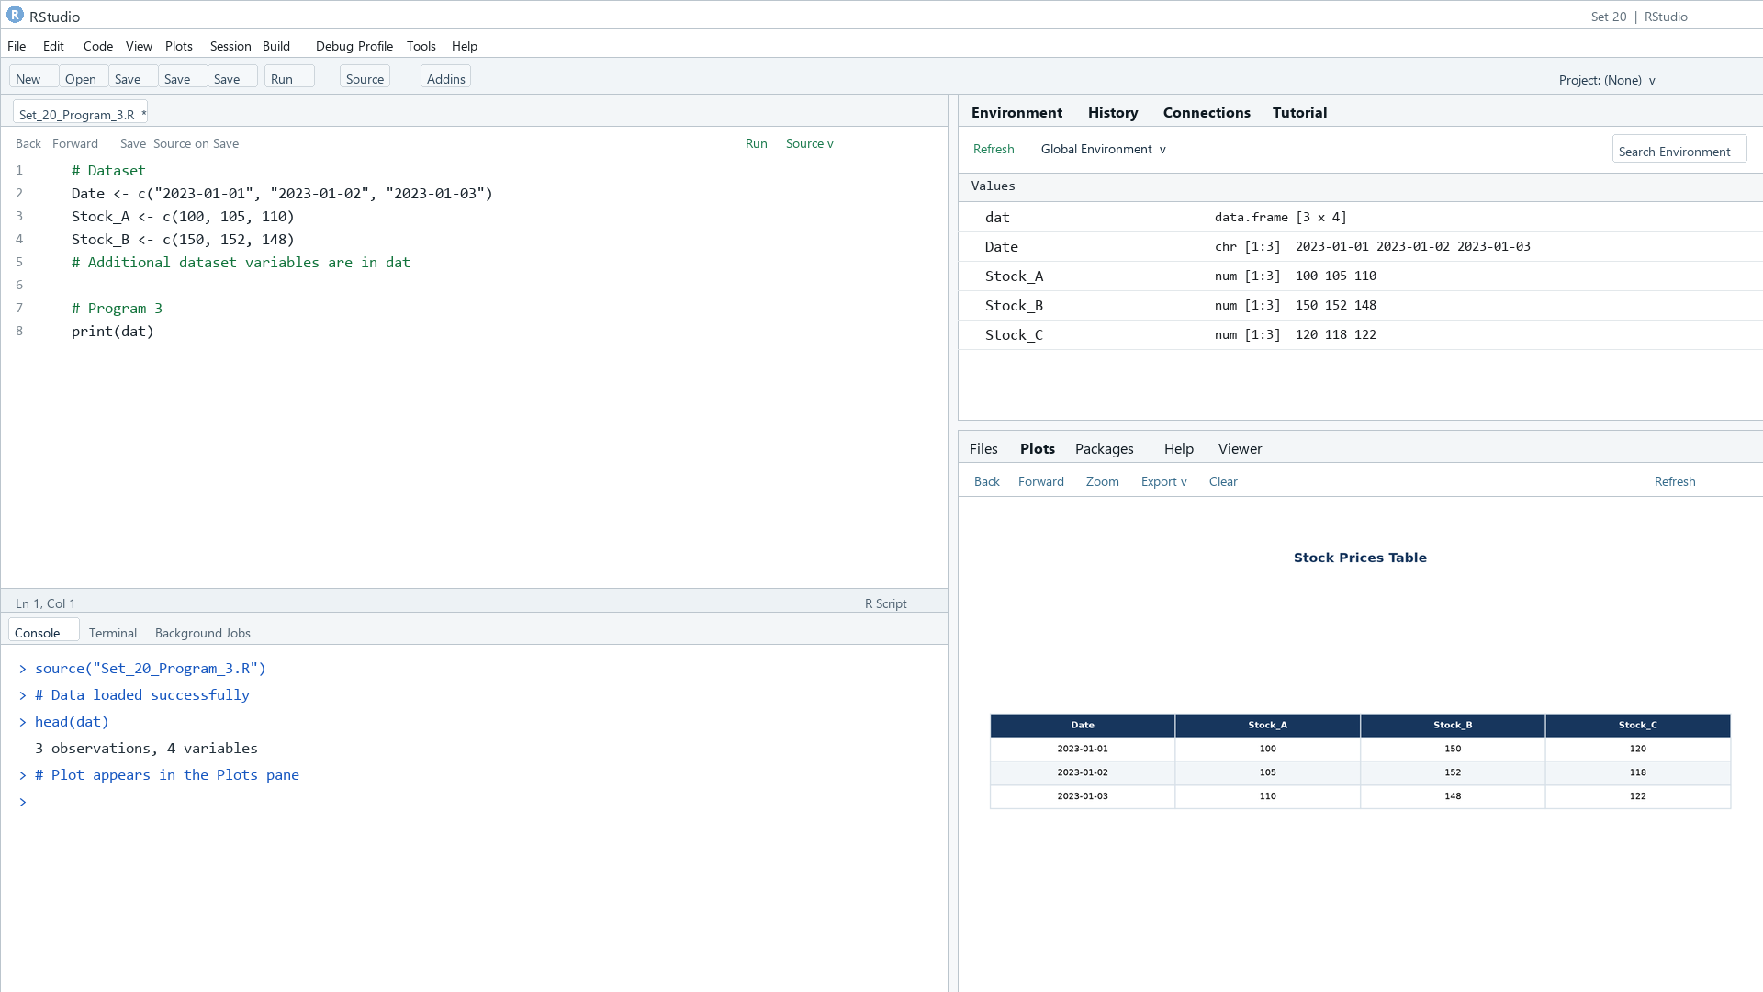

Output 3: Stock Price Data Table

Observation: The table preserves the three supplied closing-price series across the three dates.

PROGRAM 4: Stock Analysis Dashboard
Create a Tableau dashboard combining the stock line chart, daily change bar chart, and stock table.
Tableau build steps
Tableau dashboard build
1. Connect to the stock price table.
2. Pivot Stock_A, Stock_B, and Stock_C into Stock and Price fields.
3. Build a line chart by Date and Stock, plus a daily percent-change bar chart for Stock A.
4. Add the stock table and combine the views on a dashboard.

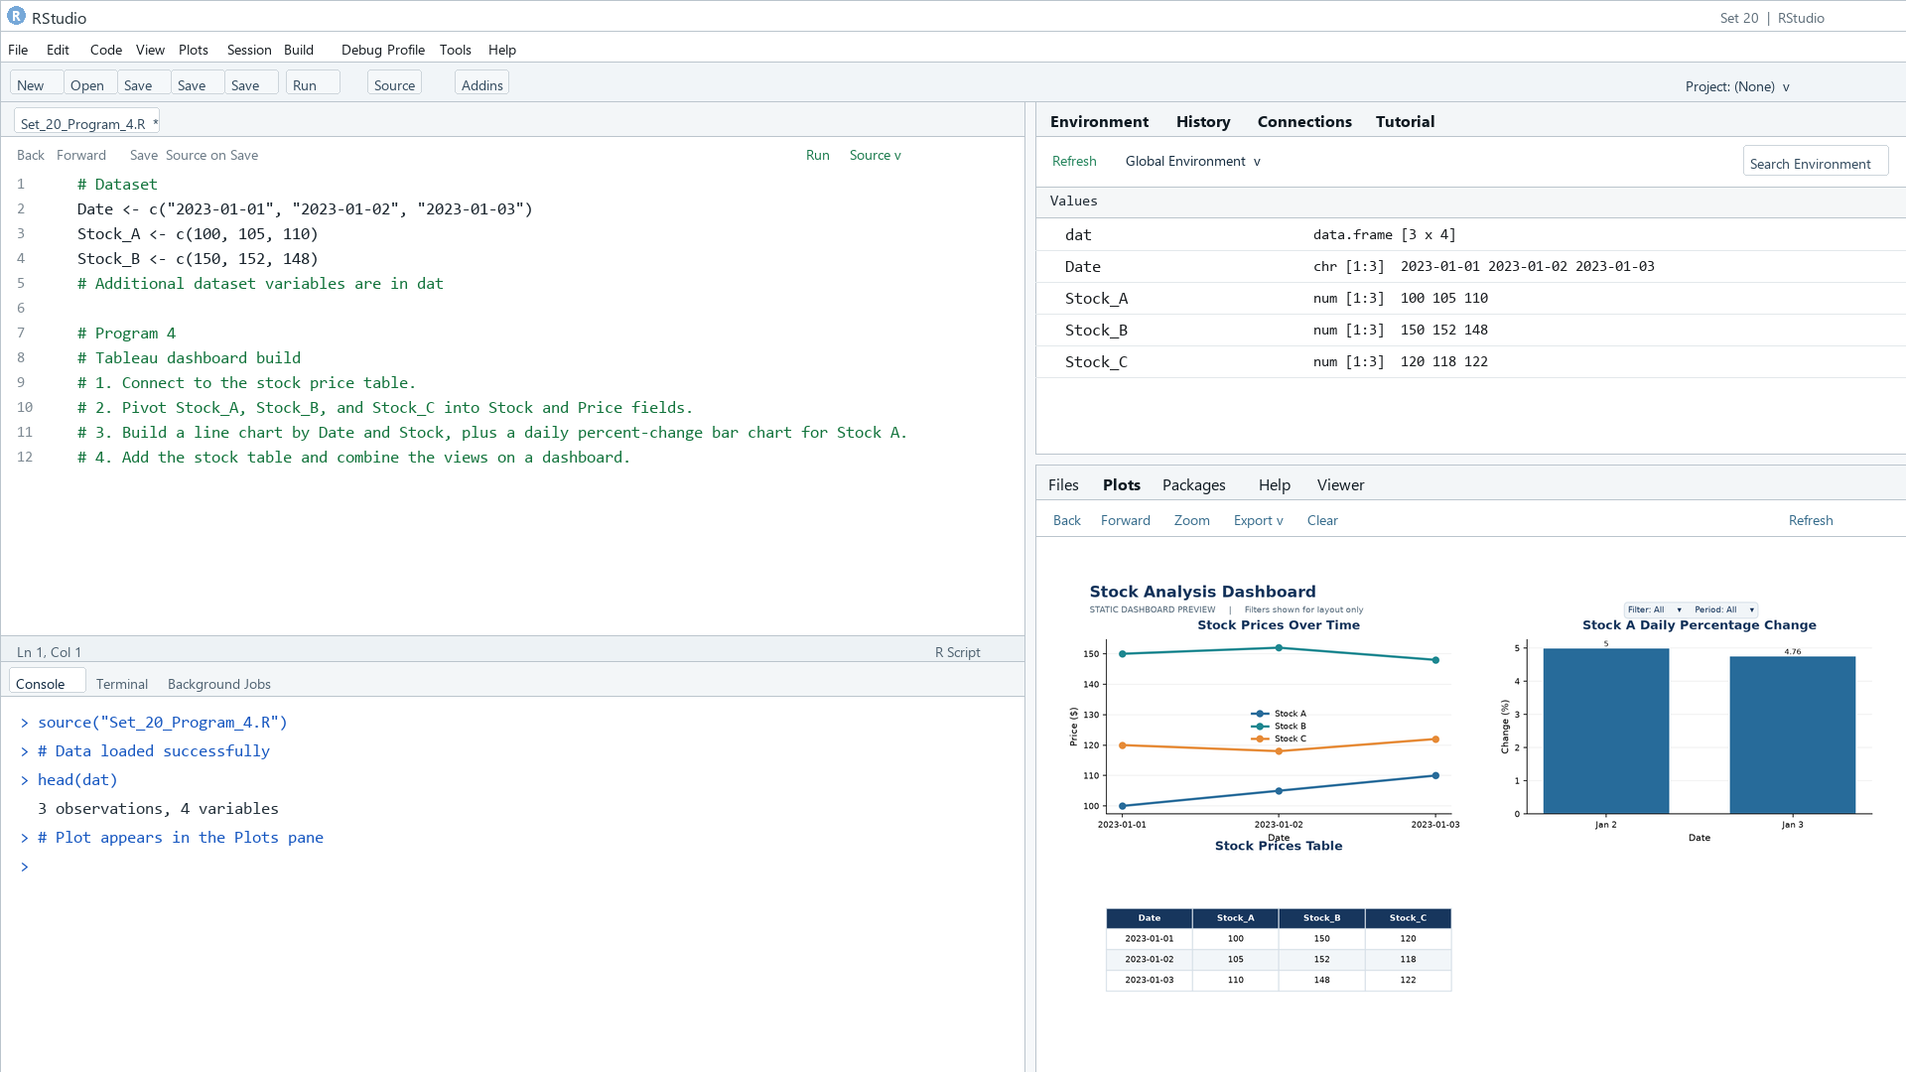

Output 4: Stock Analysis Dashboard

Observation: The preview brings the three company trends, Stock A daily changes, and the source table together.

Procedure
1. Review the dataset table and confirm any illustrative fields noted in the record.
2. Run the R setup block once, then run the requested program code.
3. Compare the output screenshot with the observation and replace illustrative values when actual data is available.
4. For Tableau tasks, connect to the displayed data and follow the dashboard build steps.

Result
The requested charts and dashboard views for Set 20 were prepared from the displayed dataset. Outputs include labels, short observations, and code or dashboard construction steps.

Key Functions Used
plot(), barplot(), hist(), boxplot(), table().

